Annexe 1. Consommation énergétique mondiale pays OCDE/non OCDE
(Qadrillions de Btu/an)
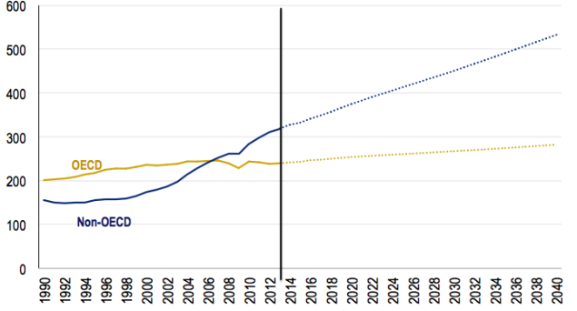
Source : U.S. Energy Information Administration. In Wolfram, C. 2016. “What the Heck Is Happening in the Developing World?” Thenergycollective, August 10
http://www.theenergycollective.com/catherinewolfram/2385109/what-the-heck-is-happening-in-the-developing-world-2

